ENG 360: Literature in a Global Context
Pirates, Prototypes, and the Americas in the British Imagination
Dr. Roberta Hurtado
roberta.hurtado@oswego.edu
Summer 2017: 11-12:50pm
Literary London, June 24-July 8, 2018

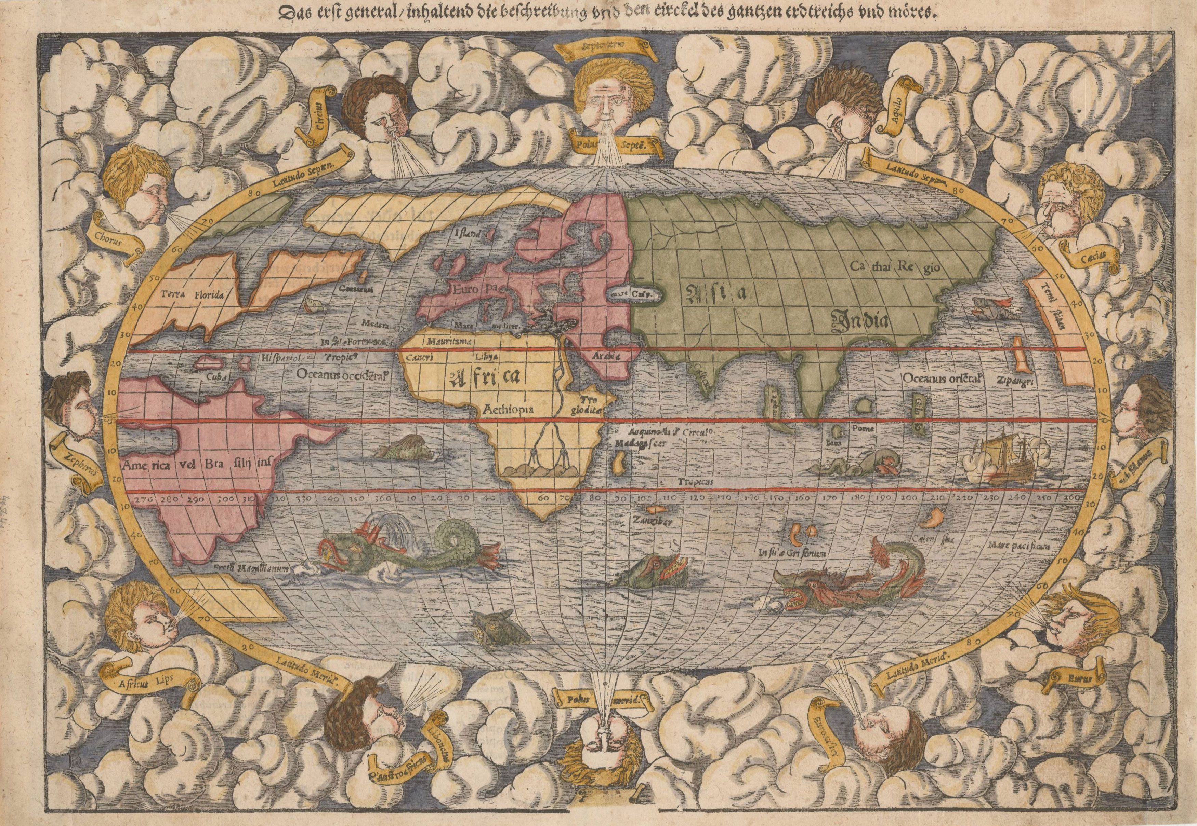

Course Description:
During the early modern period, English privateers and merchants traveled throughout the Americas straining to gain opportunities for financial gain. As part of these ventures, travel narratives emerged as arenas in which strategic information was disseminated to assist in the gradual take over of different Caribbean and North American locations. These narratives also attempted to justify this activity by forming what would become known as the “Black Legend.” Within these narratives, prototypes emerged for what would become sociosexual geo-racialized stereotypes in both the British and Anglo-U.S. cultural imagination, contributing to what Anibal Quijano describes as a “coloniality of power.” In this course, we explore travel narratives from the early modern period as they both mapped and imagined the Americas for the English imagination. Utilizing the streets of London, we will conceptualize what it means to be a foreign visitor to a previously-unknown terrain and what it means to both document that place and its people as well as inform your own cultural community about the benefits it has to offer. We will consider the kinds of details travel narratives held and must hold; the ways that such narratives constructed what the Americas would look like for their readers; and the kinds of trajectories they created for English-“American” relations in the years to come. Excursions around London, such as trips to the British Museum, will provide opportunities to witness the long lasting impact of the international trading, theft, and cultural transmissions that resulted from this earlier period and travel narratives.

Required Readings:
Behn, Aphra. The Widow Ranter.
Hariot, Thomas. A Report of the New Found Land of Virginia (1588).
Quijano, Anibal. “Coloniality and Power, Eurocentrism, and Latin America.” Nepantla vol. 1, no. 3, 2000, pp 533-80. (pdf)
Steele, Richard. “Inkle and Yarico.” The Spectator. Tuesday, March 13, 1711. (pdf)
Ligon, Richard. A True and Exact History of the Island of Barbados, Edited by Karen Kupperman, Hackett, 2011.
Games, Alison. The Web of Empire. (excerpts-pdf)

Course Requirements:
Students will compile 5 one-page narratives that document different excursions as a kind of travel journal. These must document the kinds of geographic terrains they traverse, and any pertinent details that would inform an audience of what to expect and how to access that experience in the manner of a travel narrative. These five narratives will, when compiled, provide the foundations for a short introductory essay for how travel narratives function as both imaginative explorations of different geographic locations as well as conjure the projected desires of travelers to distant lands. Participation in class discussion and excursions are vital to success in this course. Additionally, students must complete several writing assignments that are posted in our course blackboard page prior to arriving in London to prepare for the course.

Grade Distribution
Participation 20
Pre-arrival Narratives 30
Travel Journal 30
Preliminary Essay 20
_______________________________
Course Total: 100 points (100%)*

*To maintain confidentiality, no grades will be discussed over the phone or via email.

Assignments

Readings and In-Class Participation
Daily scheduled readings make up the majority of work in this course. In order to have lively, thoughtful, and interesting discussions, all students must come to class having read all outlined pages or designated sections, and have notes ready to assist in moving the conversations and analysis forward. The “participation” component of this course functions as an opportunity for professional development, in that professional settings require collaboration, individual motivation, and respect towards every member of the “team” or class. This is your class, and as such creating a positive environment conducive to learning will improve the development of professional level skills and model the kinds of intellectual communities that claim an education. And, similar to all professional settings, your behavior, input, and presence counts!

Pre-Arrival Narratives
Prior to arrival in London, you are required to complete the readings that will be discussed while abroad and conduct several entries that are due prior to your arrival. Each entry is worth five of your total 30 points for this assignment. These entries are designed to “ground” you in your new location, in a similar manner to how travel narratives grounded travellers into new locales. These assignments are all due by June 22, 2017. These assignments are to be posted into the blackboard page for our course, where grades for them will also be recorded. These assignments must be between 500-1000 words each. Recommended submission dates are provided to assist you in pacing your completion of the assignments. These entries are as follows:

Travel Narrative 1: “Tube Line Narrative”
We will be utilizing public transportation while in London, which consists of buses and subway systems. The subway in London is called “the tube,” and each route is called a “tube line.” To complete this assignment, you must 1) review the different “tube lines,” or subway maps, and 2) create a narrative in which you guide yourself around London utilizing the different tube lines. You will need to imagine that you are a traveler attempting to visit different places around London. What is one location on each tube line that you want to visit? What sort of markers are there? You might wish to use actual destinations that we are visiting as a guide to determine the places where you will visit on in this narrative and how to get to them.
Recommended Submission Date: June 1st, 2018

Travel Narrative 2: Analysis of A Report of the New Found Land of Virginia
Read A Report of the New Found Land of Virginia (1588). Imagine that you are a traveler deciding whether or not you want to go to Virginia. What sorts of things does this narrative tell you about, and the things and people you can expect to encounter? Are these things interesting to you? Do they fulfill your needs for when you will arrive in Virginia, such as having a place to live, food to eat, people to talk to, and amusements to pass the time? Use direct textual references to build your own sense of self and what you think about Virginia based on the travel narrative.
Recommended Submission Date: June 6th, 2017

Travel Narrative 3: Widow Ranter Advertisement
Read The Widow Ranter by Aphra Behn. Identify the list of characters and the order of events that occur in the drama. Create an advertisement for Virginia based on the information that the drama provides: for instance, what might someone going to Virginia expect to encounter based off of what the play has in it? Who might be there? Is it a land of adventure and intrigue, where anything can happen or is it a dangerous location where only sex-workers, thieves, and murderers live? What content/information is needed to get you to want to go to Virginia?
Recommended Submission Date: June 12th, 2017

Travel Narrative 4: Analysis A True and Exact History of the Island of Barbados
Read A True and Exact History of the Island of Barbados. Imagine that you are a traveler deciding whether or not you want to go to Barbados. What sorts of things does this narrative tell you about, and the things and people you can expect to encounter? Are these things interesting to you? Do they fulfill your needs for when you will arrive in Barbados, such as having a place to live, food to eat, people to talk to, and amusements to pass the time? Use direct textual references to build your own sense of self and what you think about Barbados based on the travel narrative.
Recommended Submission Date: June 15th, 2017

Travel Narrative 5: “Inkle and Yarico” and the Traveler’s Gaze
Read “Inkle and Yarico.” Identify all of the characters who are involved in this short story and provide a small summary of each character’s role in the internal and framing stories. Next, using these summaries, describe the kind of ethos that the lady who tells about “Inkle and Yarico” has and what this informs you about, as a traveler, regarding an English woman’s identity, morality, and sense of self. You might wish to consider the following questions to help you as you write this narrative: Is she a good person? Who, as readers, should we feel pity for, and ultimately what does the end of this short story resolve, if anything?
Recommended Submission Date: June 19th, 2017

Travel Narrative 6: “Coloniality and Power, Eurocentrism, and Latin America”
Read “Coloniality and Power, Eurocentrism, and Latin America.” Identify any connections you make between what Quiñones describes and the travel narratives, drama, and short story you read. Now, imagine that you are a person who lives in a land that has been colonized by the English. How do you view the behavior of the English colonizers and their treatment of you? You might wish to consider the things that happen to you under English domination, what happens to your family, your community, your land, your way of life, and the dreams of the future you had before their arrival.
Recommended Submission Date: June 21th, 2017

Travel Journal
While we are in England, we will be going on excursions around the city as well as the South of England to places such as Stone Henge and Oxford as well as having the opportunity to explore the capital on your own. To complete this assignment, you must select 6 different destinations and write a narrative that details your experience of that trip utilizing the “gaze” of a traveler who is attempting to send information to your homeland so that your compatriots might wish to travel to this location or even colonize it. You must consider, and show in your entries, what sorts of information would you need to share in terms of traveling/transportation, geographic location, the items that are in these locales that are desirable, and what sorts of things you compatriots can expect to experience in this location. Note: You may also treat this journal as a scrapbook, including things like ticket stubs, playbills, or photos in it, though this is not required (the 200 words per day stand either way). You are to submit these in hardcopy the next class session. The last date to complete an entry is 07/05/17. Each entry is worth 5 points, and must be at least 200 words.

Preliminary Essay
On July 6t^{h}, you will submit an introductory statement regarding an argument you wish to make about the kinds of information that travel narratives provide within a coloniality and the role that they play in enhancing the ability of that coloniality to take root. You might wish to consider what you have witnessed in London in terms of how it moved from being a relatively small city to being an international hub as a result of its many colonial exploits and travel of its servicemen abroad. In this preliminary statement, you must identify the texts that we have read that you wish to include, why you think you want to include them, and the order you want to analyze them. You might also wish to include any site visits that impact the connections you would make in the essay. This preliminary essay statement must be submitted in hard copy and will be graded not polish but on coherency and engagement.

Professionalism and Policies

Attendance and Punctuality
Attendance for every class meeting and excursion is required. Only documented medical emergencies will make an absence be excused. Due to the length and intensive nature of this course, no absences are provided for this course. You are expected to arrive to your class sessions on time and ready to participate. Excursions have a pre-determined meeting time, and prompt arrival is required to ensure being able to engage these trips in a professionally academic manner. Avoid arriving late.

Class Conduct
This course is designed to provide professional development for skills that are required in work environments. These skills include but are not limited to: team building, conflict resolution, interpersonal communication, and awareness of respectful boundaries. We should promote an environment free from shaming, blaming, or hostile language/behavior, and foster our individual accountability to the class as a whole. Please be mindful of how your language and actions might impact your peers, and how we can all frame a dialogue that allows us to speak our minds and use our voices while maintaining integrity and generosity of spirit. Further, we are guests in another country, and must ensure at all times that our behavior and activities are in line with not only appropriate etiquette in any venue but also follow SUNY Oswego protocols.

Late Work
In keeping with demands that are set in professional workspaces, and in order to assist in developing skills that will increase your success in these spaces, no late work is accepted in this class. If you will be absent from class, you need to contact your faculty before class to arrange submission of material prior to the deadline. Work—unless your absence is documented as an emergency hospital visit—will only be accepted up to pre-designated deadlines and not thereafter.

Texts
All texts must be purchased unless it is noted that you will be provided them in pdf in the reading list at the start of this syllabus. If you are unable to purchase a hardcopy, you are expected to download and print a copy so that you can take notes and make appropriate markings. All pdfs must also be downloaded and printed for use in class. All texts that are not listed as pdfs must be purchased and read prior to arrival in London.

Scholastic Integrity
SUNY Oswego is committed to Intellectual Integrity. Any form of intellectual dishonesty is a serious concern and therefore prohibited. The full policy can be found at http://www.oswego.edu/integrity
Please note that plagiarism of any form will result in a failing grade for the course. You are strongly encouraged to meet with your faculty prior to submitting any work for this class if you are concerned that you might be verging on that line. I am happy to help you up to the deadline, but after a work has been submitted it is out of my hands.

Student Services
- If you have a disabling condition, which may interfere with your ability to successfully complete this course, please contact the Office of Disability Services in 155 Campus Center or call x3358
- Your safety, whether it is creating a network of support while you are experiencing a life transition or receiving safe, confidential, and supportive assistance in the aftermath of a crime, is paramount to life, and not just this class. Please be aware of the following resources
• Mary Walker Health Center 312-4100
• Counseling Center 312-4416
• University Police 312-5555

SCHEDULE
Readings and Trips
Week 1
Monday, 06/25: Orientation and Afternoon Trip: Tower of London
Tuesday, 06/26: A Report of the New Found Land of Virginia and Trip: Museum of the Docklands
Wednesday, 06/27: A Report of the New Found Land of Virginia, and Selection from Web of Empire and Trip: British Museum
Thursday, 06/28: The Widow Ranter, Trip: Frida Khalo Exhibit and Harrods
Friday, 06/29: The Widow Ranter, Trip: Museum of Immigration

Weekend 1:
Saturday, 06/30: Individual Time Around London
Sunday: 07/01: Production at The Globe

Week 2
Monday, 07/02: Day Trip to Oxford
Tuesday, 07/03: A True and Exact History of the Island of Barbados, Trip: Museum of London and Guildhall Art Gallery, Roman Amphitheatre Ruins
Wednesday, 07/04: A True and Exact History of the Island of Barbados, Trip: Dennis Severns House
Thursday, 07/05: We will be at 9am today: “Inkle and Yarico,” Trip: Migration Museum
Friday, 07/06: “Coloniality of Power, Eurocentrism, and Latin America,” Trip: Greenwich Royal Observatory

Weekend 2:
Saturday: Individual Time Around London
Sunday: Return Trip to Heathrow

Image Link: http://bartelegallery.com/wp-content/uploads/2016/03/munster-map-Resize.jpg

